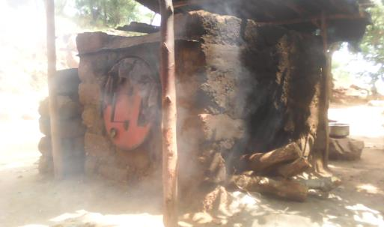
We recall that Mrs. WABIWA is among many other women who benefited from the fund to start their respective RGAs. She specialized in breadmaking and she still continues in this activity. She has become a model woman, a star and popular in her neighborhood and in the city given the selflessness with which she does her job, the ever-increasing number of her clients, and the quality of her bread. She has become a coach for women who come to her home to learn about bread making because of her experience and the positive impact of her work in her life.
Indeed ; this woman had a very difficult life, her children were not studying, her house was not equipped, the health of her children was very poor. In short, she was at the end of her life, helpless and hopeless.
Thanks to the training she received through VIBI in entrepreneurship, the guidance & support of VIBI field staff but also by the funds she had; she started her bread making business. Currently, her children are in school (4 supported by VIBI and 4 by herself), the state of health of her children is good, her house is equipped with chairs that she paid for.
ProblemThis woman is stumped by the multiple problems related to taxes on the part of the State services. Her state of health no longer allows her in any case forthe moment to do her work well. The doctor at the Panzi GRH had, moreover, ordered her to a rest of three months to recover her state of health and for the administration of the drugs which was prescribed to her;
- Fluctuations in the price of raw materials used in bread making because the exchange rate is not fixed in relation to the local currency, which is highly unstable. The price of raw materials is fixed in American dollars, while the price of bread is fixed in local currency.
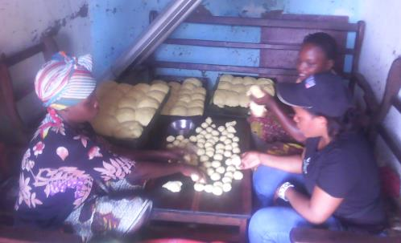
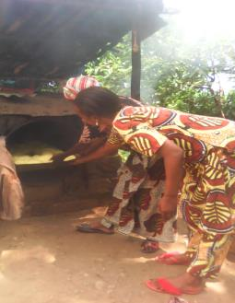

.

Proposal:
As part of the bakery project that VIBI plans to implement in the near future, given the study we are doing on this project and the resulting proposal to do a training for the facilitators of this project, we propose that this training for the leaders of the bakery project be held. About the proposal on the small bakery project that can start with a sum of 500 American dollars in accordance with the management's proposal: we suggest that this be done to preserve the achievements of this training pending the realization of the larger bakery project.
As for the benefits to be realized, we have made them clear in tables in the bakery project document that we have transmitted to you.

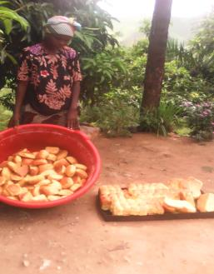
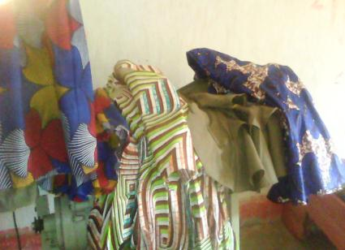

Sewing Project
Regarding the activities of the workshop, there are several challenges to be met. Indeed ; we had indeed revived this activity but some problems always arise with acuity, these include:
1. Untimely change of the tailors: We record several abandonments, several desertions of tailors in our workshop. The causes are among others: their irregularity at work (they come when they want), non-compliance with professional instructions, non-compliance with working time, non-compliance with clauses as stipulated in the collaboration agreement between VIBI and tailor .
2. There are sewn clothes that are not declared (remove their clothes) by the customers after the tailors finish. This causes a deficit for organization and stifles the operation of the workshop. This is due to the current situation prevailing throughout the national territory. We have hope because we know that customers will only end up declaring their clothes.
LOT OF SEWN CLOTHES UNCLAIMED BY CUSTOMERS

